**Appendix E**

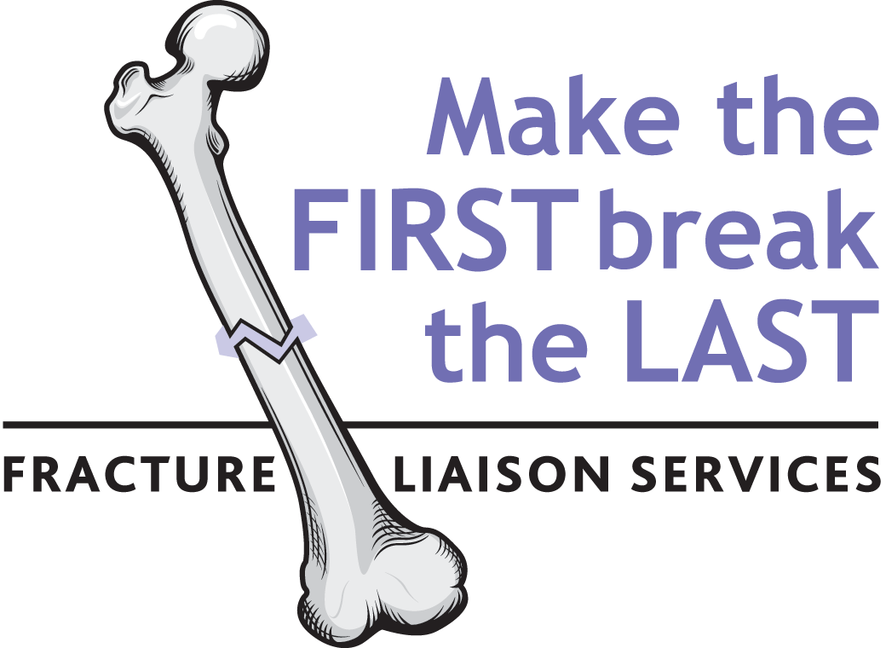

**Generic Fracture Liaison Service business plan template**

**Executive Summary**

**Fracture Liaison Services improve quality of care and save costs by reducing unscheduled emergency admissions for hip fractures and the incidence of other fragility fractures**

* **XXX** patients from [**Insert locality/healthcare system**] presented with a hip fracture to [**Insert hospital(s)/facility**] in the year **20ZZ** incurring an annual cost of **$(Y)Y,YYY,YYY.**
* Half of hip fracture patients have already suffered a previous fracture of their other hip, wrist, humerus or other skeletal sites prior to breaking their hip1-4.
* Approved osteoporosis treatments have the potential to halve the incidence of secondary hip fracture if they are initiated when patients present with their first fragility fracture5-14.
* National guidance in Canada calls for routine assessment and osteoporosis treatment, where appropriate, for patients that have suffered fragility fractures15.
* Numerous surveys conducted in Canada at the national level16, 17, provincial level18-24, and in individual organizations25-35 have documented a significant and persistent post-fracture osteoporosis care gap across Canada which has also been reported throughout the world36-39:
  + **80% of Canadian fragility fracture patients do not receive osteoporosis assessment and/or treatment after their fracture**
* Fracture Liaison Services (3i models) are endorsed by Osteoporosis Canada as the optimal model of care to eliminate the post-fracture osteoporosis care gap by ensuring that all fragility fracture sufferers receive the secondary preventive care they need40
* Fracture Liaison Services (FLS) have also been recognised by the U.S. Surgeon General41, the American Orthopaedic Association42, 43, the American Academy of Orthopaedic Surgeons44, the American Society for Bone and Mineral Research45, the National Osteoporosis Foundation and the National Bone Health Alliance46 in the United States, the International Osteoporosis Foundation36, 37 and analogous groups throughout the world47-56, as the best model to reduce the incidence of painful, debilitating and costly secondary fractures
* Successful FLS programs have been established in Canada57-63, the United States42, 43, 64-69 and many other countries70-91 which have substantially reduced the incidence of hip and other fragility fractures and significantly reduced associated costs
* [**Insert name of hospital(s)/facility**] does not have a FLS program as of [**MM-DD-YYYY**]
* Implementation of a FLS program at [**Insert name of hospital(s)/facility**] could prevent **XYZ** hip fractures over a **X** year period resulting in **$UUU,UUU** savings
* These estimates are conservative because FLS will also reduce the incidence of fractures caused by osteoporosis at skeletal sites other than the hip

**This business plan makes the case for *urgent* implementation of a Fracture Liaison Service, structured in accordance with successful models from elsewhere. This will reduce the incidence of hip and other fractures caused by osteoporosis amongst the elderly and will reduce healthcare costs**

**The need for a Fracture Liaison Service in [Insert locality/healthcare system]**

**The human and economic burden of osteoporosis in Canada**

Canada is entering a period of rapid ageing. By 2031 almost a quarter of our population will be seniors as compared to 15% in 201192. Among these, at least 1 in 3 women and 1 in 5 men will suffer a ***fragility fracture*** in their lifetime due to osteoporosis41, 93, 94, which is the most common chronic bone disease95. A fragility fracture is one occurring spontaneously or following minor trauma such as a fall from standing height or less45. These usually occur at the hip, wrist, upper arm, pelvis or spine. Hip fractures are the most devastating of all fragility fractures. About 30,000 Canadians break their hip every year96. Of these, 28% of women and 37% of men will die within the first year after fracture97. The rest will experience a significant reduction in their quality of life98-100.

The total number of fragility fractures occurring in Canada is of the order 200,000 cases per year among women and men96, 101. To put this in context, for women, this considerably exceeds the combined number of heart attacks, strokes and new diagnoses of breast cancer annually (figure 1)96, 101-103.

Figure 1. Incidence of osteoporotic fracture, heart attack, stroke and breast cancer in Canadian women96, 101-103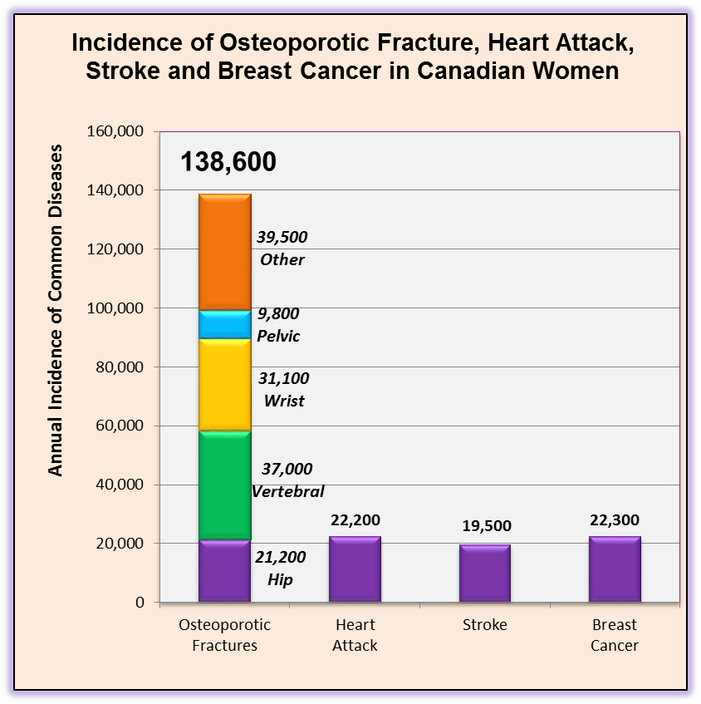

**Half of hip fracture patients warn us they are coming: *Fracture begets fracture***

Individuals who suffer a fragility fracture are at substantially increased risk of suffering second and subsequent fractures. Crucially, half of patients who suffer a hip fracture had previously broken another bone – a ‘*signal*’ fracture – before breaking their hip1-4. In other words, half of hip fracture patients had already warned us they were coming when they had their signal fracture. These data indicate the major opportunity afforded by secondary fracture prevention strategies. By responding to the first fracture, we can reduce the incidence of second and subsequent fractures, particularly of the hip36, 45, 46, 104. It is self-evident that every fracture which occurred before the hip fracture in figure 2 – every signal fracture – created an opportunity for osteoporosis assessment. Each time this opportunity was missed, the patient was left needlessly at risk and continued to suffer subsequent fractures until finally devastated by a hip fracture.

Figure 2. Osteoporosis and fragility fractures throughout the life course53

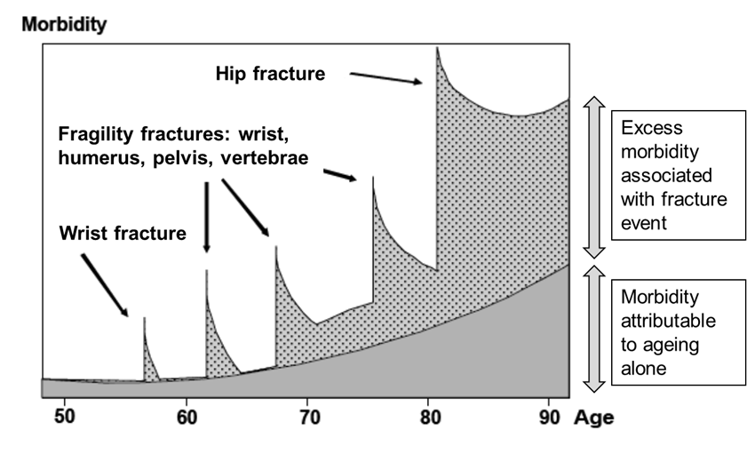

**Osteoporosis treatments can halve secondary fracture incidence**

A broad choice of medicines are available to treat osteoporosis which can be taken as daily5, 7-11, weekly105, 106 or monthly tablets107, or as daily12, semi-annual6 or annual injections13, 14. These agents have been shown to reduce the incidence of fractures by 30-50%. Fracture reduction efficacy of 50% has been observed for patients with a history of multiple fractures108. A growing body of evidence also suggests that osteoporosis treatment is associated with reduced mortality14, 109-112.

**Post-fracture osteoporosis care: A nationwide care gap**

Numerous surveys conducted in Canada at the national level16, 17, provincial level18-24, and in individual organizations25-35 have reported a significant and persistent secondary fracture prevention care gap. A significant body of work has been undertaken in Canada and internationally to understand why the post-fracture osteoporosis care gap exists and how it can be eliminated38, 39, 113-118. Put simply, there is a disconnect between the management of the fracture, usually by orthopaedic services, and recognition and management of the underlying osteoporosis (BMD testing and/or osteoporosis treatment) as follows119:

* The fracture is treated as an acute event by the orthopaedic surgeon or emergency physician who provide the best of immediate care for the fracture.
* The patient also treats their fracture as an acute event as he or she is unaware of his or her bone fragility/failure (a man who suffers a heart attack from shovelling snow blames his heart, not the snow bank – but a patient who breaks his/her wrist from a simple fall blames the floor).
* Thus, the opportunity for post-fracture intervention is missed.

**Fracture Liaison Services:**

**A proven system to eliminate the post-fracture osteoporosis care gap**

**The Fracture Liaison Service (FLS) model of care has been shown within Canada57-63, the United States42, 43, 64-69 and many other countries70-91 to eliminate the post-fracture osteoporosis care gap, reducing the incidence of repeat fractures and resulting in significant cost savings. Osteoporosis Canada calls for implementation of FLS across all Canadian provinces as a matter of urgency.**

In 2011, Canadian investigators undertook a systematic review describing clinical models intended to close the post-fracture osteoporosis care gap120. Sixty-five percent of the world’s literature described the critical role of dedicated personnel to proactively identify patients, to facilitate BMD testing and to initiate osteoporosis treatment. These service models have been referred to by a range of terms. In accordance with major international post-fracture care initiatives, this document will use the term Fracture Liaison Service (FLS)36, 37, 45, 104, 121, 122.

The main objectives of a Fracture Liaison Service (FLS) include:

* **Identification:** All men and women over 50 years of age who present with fragility fractures will be assessed for risk factors for osteoporosis and future fractures.
* **Investigation:** As per 2010 Osteoporosis Canada Guidelines15, those at risk will undergo BMD testing.
* **Initiation**: Where appropriate, osteoporosis treatment will be initiated by the FLS.

These objectives are often referred to as the **3 “i’s”**. The FLS will employ dedicated personnel, usually a nurse practitioner (NP) or a registered nurse (RN), to coordinate the fracture patient’s care. The NP can provide all 3 i’s whereas the RN can only provide the first 2 (leaving the initiation of treatment to the primary care provider). The FLS nurse(s) will work according to pre-agreed protocols within the particular institution, with input from a physician with expertise in osteoporosis.

In 2013, investigators from Australia published a systematic review and meta-analysis on post-fracture models of care which provides a useful framework for classification116. Models of varying intensity were classified as Types A to D, the description and outcomes for which are summarised in ***Make the FIRST break the LAST with Fracture Liaison Services*** and associated Appendices C and D.

**A Fracture Liaison Service (3i model) to identify, investigate, and initiate appropriate osteoporosis treatment must be the standard of care across Canada. Osteoporosis Canada urges all jurisdictions to implement FLS by 2015**.

A Type B model (2i) can be easily expanded to a Type A model within the same infrastructure. There may also be hybrid models that combine both NPs and RNs that may prove to be more cost-effective (the lower costing RNs could do the work for identification and investigation, leaving the higher costing NPs to deliver initiation).

[**The business plan authors may choose to make reference to the examples of successful FLS within Canada and leading international models referenced below**]

**Toronto:** The Osteoporosis Exemplary Care Program at St. Michael’s Hospital in Toronto established that a hospital which hired an FLS coordinator who manages 500 patients with fragility fractures annually could **reduce the number of secondary hip fractures by 9% in the first year**, with net hospital cost savings of $48,950 (2004 dollars)60, 61. Greater savings were anticipated after the first year and when additional costs such as rehabilitation and dependency costs are considered.

**Edmonton:** A formal health-economic evaluation of a coordinator to improve osteoporosis treatment after hip fracture found that for every 100 patients assessed, 6 fractures (including 4 hip fractures) were prevented, 4 quality-adjusted life years were gained, and $260,000 (2006 Canadian dollars) was saved by the healthcare system58, 59. The **intervention cost was just $56 per patient** and the intervention would break even within two years. A similar analysis which evaluated a nurse coordinating management after wrist fracture reported a cost per patient of $4457, 123.

**Australia:** Seibel MJ, Lih A, Nandapalan H et al. Targeted intervention reduces refracture rates in patients with incident non-vertebral osteoporotic fractures: a 4-year prospective controlled study. *Osteoporosis International*. 2011 Mar;22(3):849-858. [PubMed ID 21107534](http://www.ncbi.nlm.nih.gov/pubmed/21107534)

**United Kingdom:** McLellan A, Gallacher S, Fraser M et al.The fracture liaison service: success of a program for the evaluation and management of patients with osteoporotic fracture. *Osteoporosis International*. 2003;14(12):1028-1034. [PubMed ID 14600804](http://www.ncbi.nlm.nih.gov/pubmed/14600804)

**United States:** Fracture prevention in Kaiser Permanente Southern California. Dell R. Osteoporos Int. 2011 Aug;22 Suppl 3:457-460. [PubMed 21847765](http://www.ncbi.nlm.nih.gov/pubmed/21847765)

**[Insert hospital(s)/facility]** does not have a FLS program as of **[MM-DD-YYYY]**.

**A Fracture Liaison Service for [Insert hospital(s)/facility]**

**This business plan makes the case for urgent implementation of a Fracture Liaison Service in [Insert hospital(s)/facility]**, structured in accordance with successful models from elsewhere, to reduce the incidence of hip and other fractures caused by osteoporosis amongst our elderly population.

**Aim:** The aim of the proposed Fracture Liaison Service (FLS) program is to ensure that all patients age 50 and over presenting to urgent care services with fractures caused by osteoporosis receive assessment and treatment, where appropriate, for osteoporosis and referral to local falls prevention services to reduce their risk of subsequent fractures.

**Current provision:** An assessment of current service provision sets a context for funders to consider the merits of the business plan.

**Service model:** The FLS program will be structured in accordance with successful models from elsewhere.

Insert local data on the total number of hip fracture admissions and non-hip fragility fracture patients managed as in-patients and out-patients respectively. Consider producing a table as indicated below:



Provide local costs associated with hospital, primary care and any publicly funded residential/nursing home admissions related to these fractures.

Provide a comprehensive breakdown of all costs pertaining to delivery of the FLS in your province/locality/institution. In addition to Osteoporosis Canada’s ***Make the FIRST break the LAST***

***with Fracture Liaison Services*** document and associated appendices, several international initiatives provide practical resources which can support development of this component of the business plan:

**American Society for Bone and Mineral Research**

Eisman JA, Bogoch ER, Dell R et al. Making the first fracture the last fracture: ASBMR task force report on secondary fracture prevention. J Bone Miner Res. 2012 Oct;27(10):2039-2046. [PubMed ID 22836222](http://www.ncbi.nlm.nih.gov/pubmed/22836222)

Appendix A is recommended reading and available under Supporting Information at: <http://onlinelibrary.wiley.com/doi/10.1002/jbmr.1698/abstract>

**International Osteoporosis Foundation**

Capture the Fracture Campaign and Best Practice Framework

Akesson K, Marsh D, Mitchell PJ et al. Capture the Fracture: a Best Practice Framework and global campaign to break the fragility fracture cycle. Osteoporos Int. 2013 Apr 16. [Epub ahead of print]. [PubMed ID 23589162](http://www.ncbi.nlm.nih.gov/pubmed/23589162)

The Capture the Fracture Campaign website is also recommended reading at: <http://www.capturethefracture.org/>

**National Bone Health Alliance (United States)**

The National Bone Health Alliance in the United States has developed the Fracture Prevention CENTRAL website to promote the widespread implementation of post-fracture prevention and care coordination programs:

<http://www.nbha.org/fpc>

**Glasgow Fracture Liaison Service, Scotland UK**

The publication of a formal cost-effectiveness model for the Glasgow FLS in Scotland, UK can serve as a useful check-list to consider what elements should be taken into account by those planning implementation of FLS. See table 1 of the Glasgow FLS formal cost-effectiveness publication:

McLellan AR, Wolowacz SE, Zimovetz EA et al. Fracture liaison services for the evaluation and management of patients with osteoporotic fracture: a cost-effectiveness evaluation based on data collected over 8 years of service provision. Osteoporos Int. 2011 Jul;22(7):2083-2098. [PubMed ID 21607809](http://www.ncbi.nlm.nih.gov/pubmed/21607809)

**Summary**

Hip fractures exert a substantial toll on our local elderly population and on our healthcare budgets. Half of hip fracture patients had already warned us they were coming because they suffered prior fractures caused by osteoporosis that could and should have served as a trigger for secondary preventive care.

Implementation of a **Fracture Liaison Service** in **[Insert hospital(s)/facility]** will eliminate the post-fracture osteoporosis care gap in our locality. The Fracture Liaison Service will improve the quality of care we give and reduce costs associated with preventable fractures. This business plan recommends implementation of this service as a matter of urgency.

**References**

**1.** Gallagher JC, Melton LJ, Riggs BL, Bergstrath E. Epidemiology of fractures of the proximal femur in Rochester, Minnesota. *Clin Orthop Relat Res.* Jul-Aug 1980(150):163-171.

**2.** Port L, Center J, Briffa NK, Nguyen T, Cumming R, Eisman J. Osteoporotic fracture: missed opportunity for intervention. *Osteoporos Int.* Sep 2003;14(9):780-784.

**3.** McLellan A, Reid D, Forbes K, et al. *Effectiveness of Strategies for the Secondary Prevention of Osteoporotic Fractures in Scotland (CEPS 99/03)*: NHS Quality Improvement Scotland; 2004.

**4.** Edwards BJ, Bunta AD, Simonelli C, Bolander M, Fitzpatrick LA. Prior fractures are common in patients with subsequent hip fractures. *Clin Orthop Relat Res.* Aug 2007;461:226-230.

**5.** Black DM, Cummings SR, Karpf DB, et al. Randomised trial of effect of alendronate on risk of fracture in women with existing vertebral fractures. Fracture Intervention Trial Research Group. *Lancet.* Dec 7 1996;348(9041):1535-1541.

**6.** Cummings SR, San Martin J, McClung MR, et al. Denosumab for prevention of fractures in postmenopausal women with osteoporosis. *N Engl J Med.* Aug 20 2009;361(8):756-765.

**7.** Torgerson DJ, Bell-Syer SE. Hormone replacement therapy and prevention of nonvertebral fractures: a meta-analysis of randomized trials. *JAMA.* Jun 13 2001;285(22):2891-2897.

**8.** Ettinger B, Black DM, Mitlak BH, et al. Reduction of vertebral fracture risk in postmenopausal women with osteoporosis treated with raloxifene: results from a 3-year randomized clinical trial. Multiple Outcomes of Raloxifene Evaluation (MORE) Investigators. *JAMA.* Aug 18 1999;282(7):637-645.

**9.** McClung MR, Geusens P, Miller PD, et al. Effect of risedronate on the risk of hip fracture in elderly women. Hip Intervention Program Study Group. *N Engl J Med.* Feb 1 2001;344(5):333-340.

**10.** Reginster J, Minne HW, Sorensen OH, et al. Randomized trial of the effects of risedronate on vertebral fractures in women with established postmenopausal osteoporosis. Vertebral Efficacy with Risedronate Therapy (VERT) Study Group. *Osteoporos Int.* 2000;11(1):83-91.

**11.** Harris ST, Watts NB, Genant HK, et al. Effects of risedronate treatment on vertebral and nonvertebral fractures in women with postmenopausal osteoporosis: a randomized controlled trial. Vertebral Efficacy With Risedronate Therapy (VERT) Study Group. *JAMA.* Oct 13 1999;282(14):1344-1352.

**12.** Neer RM, Arnaud CD, Zanchetta JR, et al. Effect of parathyroid hormone (1-34) on fractures and bone mineral density in postmenopausal women with osteoporosis. *N Engl J Med.* May 10 2001;344(19):1434-1441.

**13.** Black DM, Delmas PD, Eastell R, et al. Once-yearly zoledronic acid for treatment of postmenopausal osteoporosis. *N Engl J Med.* May 3 2007;356(18):1809-1822.

**14.** Lyles KW, Colon-Emeric CS, Magaziner JS, et al. Zoledronic Acid in Reducing Clinical Fracture and Mortality after Hip Fracture. *N Engl J Med.* 2007;357:nihpa40967.

**15.** Papaioannou A, Morin S, Cheung AM, et al. 2010 clinical practice guidelines for the diagnosis and management of osteoporosis in Canada: summary. *CMAJ.* Nov 23 2010;182(17):1864-1873.

**16.** Fraser LA, Ioannidis G, Adachi JD, et al. Fragility fractures and the osteoporosis care gap in women: the Canadian Multicentre Osteoporosis Study. *Osteoporos Int.* Mar 2011;22(3):789-796.

**17.** Papaioannou A, Kennedy CC, Ioannidis G, et al. The osteoporosis care gap in men with fragility fractures: the Canadian Multicentre Osteoporosis Study. *Osteoporos Int.* Apr 2008;19(4):581-587.

**18.** Leslie WD, Giangregorio LM, Yogendran M, et al. A population-based analysis of the post-fracture care gap 1996-2008: the situation is not improving. *Osteoporos Int.* May 2012;23(5):1623-1629.

**19.** Leslie WD, Brennan SL, Prior HJ, Lix LM, Metge C, Elias B. The post-fracture care gap among Canadian First Nations peoples: a retrospective cohort study. *Osteoporos Int.* Mar 2012;23(3):929-936.

**20.** Metge CJ, Leslie WD, Manness LJ, et al. Postfracture care for older women: gaps between optimal care and actual care. *Can Fam Physician.* Sep 2008;54(9):1270-1276.

**21.** Jaglal SB, Cameron C, Hawker GA, et al. Development of an integrated-care delivery model for post-fracture care in Ontario, Canada. *Osteoporos Int.* 2006;17(9):1337-1345.

**22.** Bessette L, Ste-Marie LG, Jean S, et al. The care gap in diagnosis and treatment of women with a fragility fracture. *Osteoporos Int.* Jan 2008;19(1):79-86.

**23.** Perreault S, Dragomir A, Desgagne A, et al. Trends and determinants of antiresorptive drug use for osteoporosis among elderly women. *Pharmacoepidemiol Drug Saf.* Oct 2005;14(10):685-695.

**24.** Vanasse A, Dagenais P, Niyonsenga T, Gregoire JP, Courteau J, Hemiari A. Bone mineral density measurement and osteoporosis treatment after a fragility fracture in older adults: regional variation and determinants of use in Quebec. *BMC Musculoskelet Disord.* 2005;6:33.

**25.** Khan SA, de Geus C, Holroyd B, Russell AS. Osteoporosis follow-up after wrist fractures following minor trauma. *Arch Intern Med.* May 28 2001;161(10):1309-1312.

**26.** Juby AG, De Geus-Wenceslau CM. Evaluation of osteoporosis treatment in seniors after hip fracture. *Osteoporos Int.* Mar 2002;13(3):205-210.

**27.** Meadows LM, Mrkonjic LA, O'Brien MD, Tink W. The importance of communication in secondary fragility fracture treatment and prevention. *Osteoporos Int.* Feb 2007;18(2):159-166.

**28.** Singh S, Foster R, Khan KM. Accident or osteoporosis?: Survey of community follow-up after low-trauma fracture. *Can Fam Physician.* Apr 2011;57(4):e128-133.

**29.** Davis JC, Ashe MC, Guy P, Khan KM. Undertreatment after hip fracture: a retrospective study of osteoporosis overlooked. *J Am Geriatr Soc.* Jun 2006;54(6):1019-1020.

**30.** Ashe MC, McKay HA, Janssen P, Guy P, Khan KM. Improving osteoporosis management in at-risk fracture clinic patients. *J Am Geriatr Soc.* Apr 2005;53(4):727-728.

**31.** Byszewski A, Lemay G, Molnar F, Azad N, McMartin SE. Closing the osteoporosis care gap in hip fracture patients: an opportunity to decrease recurrent fractures and hospital admissions. *J Osteoporos.* 2011;2011:404969.

**32.** Petrella RJ, Jones TJ. Do patients receive recommended treatment of osteoporosis following hip fracture in primary care? *BMC Fam Pract.* 2006;7:31.

**33.** Hamel ME, Sebaldt RJ, Siminoski K, et al. Influence of fracture history and bone mineral density testing on the treatment of osteoporosis in two non-academic community centers. *Osteoporos Int.* Feb 2005;16(2):208-215.

**34.** Hajcsar EE, Hawker G, Bogoch ER. Investigation and treatment of osteoporosis in patients with fragility fractures. *CMAJ.* Oct 3 2000;163(7):819-822.

**35.** Khandwala HM, Kolla N, Grover VK. Evaluation and treatment of osteoporosis in patients with a fragility hip fracture. *Endocr Pract.* Nov-Dec 2005;11(6):370-375.

**36.** International Osteoporosis Foundation. *Capture the Fracture: A global campaign to break the fragility fracture cycle.* Nyon 2012.

**37.** International Osteoporosis Foundation. Capture the Fracture: Break the worldwide fragility fracture cycle. http://www.capturethefracture.org/. Accessed 21 June 2013.

**38.** Elliot-Gibson V, Bogoch ER, Jamal SA, Beaton DE. Practice patterns in the diagnosis and treatment of osteoporosis after a fragility fracture: a systematic review. *Osteoporos Int.* Oct 2004;15(10):767-778.

**39.** Giangregorio L, Papaioannou A, Cranney A, Zytaruk N, Adachi JD. Fragility fractures and the osteoporosis care gap: an international phenomenon. *Semin Arthritis Rheum.* Apr 2006;35(5):293-305.

**40.** Osteoporosis Canada. *Osteoporosis: Towards a fracture free future.* Toronto 2011.

**41.** Office of the Surgeon General. Bone Health and Osteoporosis: A Report of the Surgeon General. In: US Department of Health and Human Services, ed. Washington; 2004.

**42.** Tosi LL, Gliklich R, Kannan K, Koval KJ. The American Orthopaedic Association's "own the bone" initiative to prevent secondary fractures. *J Bone Joint Surg Am.* Jan 2008;90(1):163-173.

**43.** American Orthopaedic Association. Own the Bone website. http://www.ownthebone.org/. Accessed 17 January 2012.

**44.** American Academy of Orthopaedic Surgeons, American Association of Orthopaedic Surgeons. Position Statement: Recommendations for Enhancing the Care of Patients with Fragility Fractures. http://www.aaos.org/about/papers/position/1159.asp. Accessed 10 December 2012.

**45.** Eisman JA, Bogoch ER, Dell R, et al. Making the first fracture the last fracture: ASBMR task force report on secondary fracture prevention. *J Bone Miner Res.* Oct 2012;27(10):2039-2046.

**46.** National Bone Health Alliance. NBHA Secondary Fracture Prevention Initiative. http://www.nbha.org/projects/secondary-fracture-prevention-initiative. Accessed 4 February 2013.

**47.** Dreinhofer KE, Feron JM, Herrera A, et al. Orthopaedic surgeons and fragility fractures. A survey by the Bone and Joint Decade and the International Osteoporosis Foundation. *J Bone Joint Surg Br.* Sep 2004;86(7):958-961.

**48.** International Society for Fracture Repair. Osteoporotic Fracture Campaign. http://www.fractures.com/about_ofc.html. Accessed 28-10-2011.

**49.** NSW Government Health. NSW Model of Care for Osteoporotic Refracture Prevention. In: NSW Agency for Clinical Innovation Musculoskeletal Network, ed. Chatswood; 2011.

**50.** Statewide Orthopaedic Clinical Network and Rehabilitation Clinical Network. Models of Care for Orthopaedic Rehabilitation - Fragility Fractures General Orthopaedic Trauma and Arthroplasty. In: Government of South Australia, SA Health, eds. Adelaide; 2011.

**51.** Government of Western Australia. Osteoporosis Model of Care. In: Department of Health Musculoskeletal Diabetes & Endocrine Falls Prevention and Aged Care Health Networks (WA), ed. Perth; 2011.

**52.** Osteoporosis New Zealand. *Bone Care 2020: A systematic approach to hip fracture care and prevention for New Zealand.* Wellington 2012.

**53.** British Orthopaedic Association, British Geriatrics Society. *The care of patients with fragility fracture* 2007.

**54.** National Osteoporosis Society. *Protecting fragile bones: A strategy to reduce the impact of osteoporosis and fragility fractures in England/Scotland/Wales/Northern Ireland* May-Jun 2009 2009.

**55.** Department of Health. Fracture prevention services: an economic evaluation.; 2009.

**56.** Department of Health. Falls and fractures: Effective interventions in health and social care. In: Department of Health, ed; 2009.

**57.** Majumdar SR, Johnson JA, Bellerose D, et al. Nurse case-manager vs multifaceted intervention to improve quality of osteoporosis care after wrist fracture: randomized controlled pilot study. *Osteoporos Int.* Jan 2011;22(1):223-230.

**58.** Majumdar SR, Lier DA, Beaupre LA, et al. Osteoporosis case manager for patients with hip fractures: results of a cost-effectiveness analysis conducted alongside a randomized trial. *Arch Intern Med.* Jan 12 2009;169(1):25-31.

**59.** Majumdar SR, Beaupre LA, Harley CH, et al. Use of a case manager to improve osteoporosis treatment after hip fracture: results of a randomized controlled trial. *Arch Intern Med.* Oct 22 2007;167(19):2110-2115.

**60.** Sander B, Elliot-Gibson V, Beaton DE, Bogoch ER, Maetzel A. A coordinator program in post-fracture osteoporosis management improves outcomes and saves costs. *J Bone Joint Surg Am.* Jun 2008;90(6):1197-1205.

**61.** Bogoch ER, Elliot-Gibson V, Beaton DE, Jamal SA, Josse RG, Murray TM. Effective initiation of osteoporosis diagnosis and treatment for patients with a fragility fracture in an orthopaedic environment. *J Bone Joint Surg Am.* Jan 2006;88(1):25-34.

**62.** Morrish DW, Beaupre LA, Bell NR, et al. Facilitated bone mineral density testing versus hospital-based case management to improve osteoporosis treatment for hip fracture patients: additional results from a randomized trial. *Arthritis Rheum.* Feb 15 2009;61(2):209-215.

**63.** Roux S, Beaulieu M, Beaulieu MC, Cabana F, Boire G. Priming primary care physicians to treat osteoporosis after a fragility fracture: an integrated multidisciplinary approach. *J Rheumatol.* May 2013;40(5):703-711.

**64.** Dell R. Fracture prevention in Kaiser Permanente Southern California. *Osteoporos Int.* Aug 2011;22 Suppl 3:457-460.

**65.** Dell R, Greene D, Schelkun SR, Williams K. Osteoporosis disease management: the role of the orthopaedic surgeon. *J Bone Joint Surg Am.* Nov 2008;90 Suppl 4:188-194.

**66.** Newman ED, Ayoub WT, Starkey RH, Diehl JM, Wood GC. Osteoporosis disease management in a rural health care population: hip fracture reduction and reduced costs in postmenopausal women after 5 years. *Osteoporos Int.* Apr 2003;14(2):146-151.

**67.** Geisinger Health System. Osteoporosis. http://www.geisinger.org/professionals/services/osteo/index.html. Accessed 21-01-2013.

**68.** Harrington JT, Barash HL, Day S, Lease J. Redesigning the care of fragility fracture patients to improve osteoporosis management: a health care improvement project. *Arthritis Rheum.* Apr 15 2005;53(2):198-204.

**69.** Edwards BJ, Bunta AD, Madison LD, et al. An osteoporosis and fracture intervention program increases the diagnosis and treatment for osteoporosis for patients with minimal trauma fractures. *Jt Comm J Qual Patient Saf.* May 2005;31(5):267-274.

**70.** Giles M, Van Der Kallen J, Parker V, et al. A team approach: implementing a model of care for preventing osteoporosis related fractures. *Osteoporos Int.* Aug 2011;22(8):2321-2328.

**71.** Kuo I, Ong C, Simmons L, Bliuc D, Eisman J, Center J. Successful direct intervention for osteoporosis in patients with minimal trauma fractures. *Osteoporos Int.* Dec 2007;18(12):1633-1639.

**72.** Lih A, Nandapalan H, Kim M, et al. Targeted intervention reduces refracture rates in patients with incident non-vertebral osteoporotic fractures: a 4-year prospective controlled study. *Osteoporos Int.* Mar 2011;22(3):849-858.

**73.** Vaile J, Sullivan L, Bennett C, Bleasel J. First Fracture Project: addressing the osteoporosis care gap. *Intern Med J.* Oct 2007;37(10):717-720.

**74.** Inderjeeth CA, Glennon DA, Poland KE, et al. A multimodal intervention to improve fragility fracture management in patients presenting to emergency departments. *Med J Aust.* Aug 2 2010;193(3):149-153.

**75.** Ward SE, Laughren JJ, Escott BG, Elliot-Gibson V, Bogoch ER, Beaton DE. A program with a dedicated coordinator improved chart documentation of osteoporosis after fragility fracture. *Osteoporos Int.* Aug 2007;18(8):1127-1136.

**76.** Boudou L, Gerbay B, Chopin F, Ollagnier E, Collet P, Thomas T. Management of osteoporosis in fracture liaison service associated with long-term adherence to treatment. *Osteoporos Int.* Jul 2011;22(7):2099-2106.

**77.** Ahmed M, Durcan L, O'Beirne J, Quinlan J, Pillay I. Fracture liaison service in a non-regional orthopaedic clinic--a cost-effective service. *Ir Med J.* Jan 2012;105(1):24, 26-27.

**78.** Blonk MC, Erdtsieck RJ, Wernekinck MG, Schoon EJ. The fracture and osteoporosis clinic: 1-year results and 3-month compliance. *Bone.* Jun 2007;40(6):1643-1649.

**79.** Huntjens KM, van Geel TA, Blonk MC, et al. Implementation of osteoporosis guidelines: a survey of five large fracture liaison services in the Netherlands. *Osteoporos Int.* Jul 2011;22(7):2129-2135.

**80.** Huntjens KM, van Geel TC, Geusens PP, et al. Impact of guideline implementation by a fracture nurse on subsequent fractures and mortality in patients presenting with non-vertebral fractures. *Injury.* Sep 2011;42 Suppl 4:S39-43.

**81.** van Helden S, Cauberg E, Geusens P, Winkes B, van der Weijden T, Brink P. The fracture and osteoporosis outpatient clinic: an effective strategy for improving implementation of an osteoporosis guideline. *J Eval Clin Pract.* Oct 2007;13(5):801-805.

**82.** Astrand J, Nilsson J, Thorngren KG. Screening for osteoporosis reduced new fracture incidence by almost half. *Acta Orthop.* Dec 2012;83(6):661-665.

**83.** Chandran M, Tan MZ, Cheen M, Tan SB, Leong M, Lau TC. Secondary prevention of osteoporotic fractures-an "OPTIMAL" model of care from Singapore. *Osteoporos Int.* Apr 25 2013.

**84.** Carpintero P, Gil-Garay E, Hernandez-Vaquero D, Ferrer H, Munuera L. Interventions to improve inpatient osteoporosis management following first osteoporotic fracture: the PREVENT project. *Arch Orthop Trauma Surg.* Feb 2009;129(2):245-250.

**85.** Chevalley T, Hoffmeyer P, Bonjour JP, Rizzoli R. An osteoporosis clinical pathway for the medical management of patients with low-trauma fracture. *Osteoporos Int.* 2002;13(6):450-455.

**86.** Stone D. Managing osteoporosis in a rural community. *Nurs Times.* Jun 12-18 2012;108(24):25-27.

**87.** Wallace I, Callachand F, Elliott J, Gardiner P. An evaluation of an enhanced fracture liaison service as the optimal model for secondary prevention of osteoporosis. *JRSM Short Rep.* 2011;2(2):8.

**88.** Premaor MO, Pilbrow L, Tonkin C, Adams M, Parker RA, Compston J. Low rates of treatment in postmenopausal women with a history of low trauma fractures: results of audit in a Fracture Liaison Service. *QJM.* Jan 2010;103(1):33-40.

**89.** Clunie G, Stephenson S. Implementing and running a fracture liaison service: An integrated clinical service providing a comprehensive bone health assessment at the point of fracture management. *Journal of Orthopaedic Nursing.* 2008;12:156-162.

**90.** Wright SA, McNally C, Beringer T, Marsh D, Finch MB. Osteoporosis fracture liaison experience: the Belfast experience. *Rheumatol Int.* Aug 2005;25(6):489-490.

**91.** McLellan AR, Gallacher SJ, Fraser M, McQuillian C. The fracture liaison service: success of a program for the evaluation and management of patients with osteoporotic fracture. *Osteoporos Int.* Dec 2003;14(12):1028-1034.

**92.** Statistics Canada. *Population Projections for Canada, Provinces and Territories 2009 to 2036.* Ottawa, Ontario 2010.

**93.** van Staa TP, Dennison EM, Leufkens HG, Cooper C. Epidemiology of fractures in England and Wales. *Bone.* Dec 2001;29(6):517-522.

**94.** Kanis JA, McCloskey EV, Johansson H, et al. European guidance for the diagnosis and management of osteoporosis in postmenopausal women. *Osteoporos Int.* Oct 19 2012.

**95.** Mauck KF, Clarke BL. Diagnosis, screening, prevention, and treatment of osteoporosis. *Mayo Clin Proc.* May 2006;81(5):662-672.

**96.** Leslie WD, O'Donnell S, Lagace C, et al. Population-based Canadian hip fracture rates with international comparisons. *Osteoporos Int.* Aug 2010;21(8):1317-1322.

**97.** Jiang HX, Majumdar SR, Dick DA, et al. Development and initial validation of a risk score for predicting in-hospital and 1-year mortality in patients with hip fractures. *J Bone Miner Res.* Mar 2005;20(3):494-500.

**98.** Papaioannou A, Kennedy CC, Ioannidis G, et al. The impact of incident fractures on health-related quality of life: 5 years of data from the Canadian Multicentre Osteoporosis Study. *Osteoporos Int.* May 2009;20(5):703-714.

**99.** Adachi JD, Ioannidis G, Pickard L, et al. The association between osteoporotic fractures and health-related quality of life as measured by the Health Utilities Index in the Canadian Multicentre Osteoporosis Study (CaMos). *Osteoporos Int.* Nov 2003;14(11):895-904.

**100.** Adachi JD, Loannidis G, Berger C, et al. The influence of osteoporotic fractures on health-related quality of life in community-dwelling men and women across Canada. *Osteoporos Int.* 2001;12(11):903-908.

**101.** Burge R, Dawson-Hughes B, Solomon DH, Wong JB, King A, Tosteson A. Incidence and economic burden of osteoporosis-related fractures in the United States, 2005-2025. *J Bone Miner Res.* Mar 2007;22(3):465-475.

**102.** Public Health Agency of Canada. *2009 Tracking Heart Disease and Stroke in Canada.* Ottawa, Ontario 2009.

**103.** Canadian Cancer Society/National Cancer Institute of Canada. *Canadian Cancer Statistics.* Toronto, Canada 2007.

**104.** Marsh D, Akesson K, Beaton DE, et al. Coordinator-based systems for secondary prevention in fragility fracture patients. *Osteoporos Int.* Jul 2011;22(7):2051-2065.

**105.** Harris ST, Watts NB, Li Z, Chines AA, Hanley DA, Brown JP. Two-year efficacy and tolerability of risedronate once a week for the treatment of women with postmenopausal osteoporosis. *Curr Med Res Opin.* May 2004;20(5):757-764.

**106.** Rizzoli R, Greenspan SL, Bone G, 3rd, et al. Two-year results of once-weekly administration of alendronate 70 mg for the treatment of postmenopausal osteoporosis. *J Bone Miner Res.* Nov 2002;17(11):1988-1996.

**107.** McClung MR, Zanchetta JR, Racewicz A, et al. Efficacy and safety of risedronate 150-mg once a month in the treatment of postmenopausal osteoporosis: 2-year data. *Osteoporos Int.* Jun 30 2012.

**108.** Ensrud KE, Black DM, Palermo L, et al. Treatment with alendronate prevents fractures in women at highest risk: results from the Fracture Intervention Trial. *Arch Intern Med.* Dec 8-22 1997;157(22):2617-2624.

**109.** Beaupre LA, Morrish DW, Hanley DA, et al. Oral bisphosphonates are associated with reduced mortality after hip fracture. *Osteoporos Int.* Mar 2011;22(3):983-991.

**110.** Center JR, Bliuc D, Nguyen ND, Nguyen TV, Eisman JA. Osteoporosis medication and reduced mortality risk in elderly women and men. *J Clin Endocrinol Metab.* Apr 2011;96(4):1006-1014.

**111.** Sambrook PN, Cameron ID, Chen JS, et al. Oral bisphosphonates are associated with reduced mortality in frail older people: a prospective five-year study. *Osteoporos Int.* Sep 2011;22(9):2551-2556.

**112.** Bolland MJ, Grey AB, Gamble GD, Reid IR. Effect of osteoporosis treatment on mortality: a meta-analysis. *J Clin Endocrinol Metab.* Mar 2010;95(3):1174-1181.

**113.** Chakravarthy J, Ali A, Iyengar S, Porter K. Secondary prevention of fragility fractures by orthopaedic teams in the UK: a national survey. *Int J Clin Pract.* Mar 2008;62(3):382-387.

**114.** Chami G, Jeys L, Freudmann M, Connor L, Siddiqi M. Are osteoporotic fractures being adequately investigated? A questionnaire of GP & orthopaedic surgeons. *BMC Fam Pract.* 2006;7:7.

**115.** Dreinhofer KE, Anderson M, Feron JM, et al. Multinational survey of osteoporotic fracture management. *Osteoporos Int.* Mar 2005;16 Suppl 2:S44-53.

**116.** Ganda K, Puech M, Chen JS, et al. Models of care for the secondary prevention of osteoporotic fractures: a systematic review and meta-analysis. *Osteoporos Int.* Jul 25 2012.

**117.** Kurup HV, Andrew JG. Secondary prevention of osteoporosis after Colles fracture: Current practice. *Joint Bone Spine.* Jan 2008;75(1):50-52.

**118.** Little EA, Eccles MP. A systematic review of the effectiveness of interventions to improve post-fracture investigation and management of patients at risk of osteoporosis. *Implement Sci.* 2010;5:80.

**119.** Harrington J. Dilemmas in providing osteoporosis care for fragility fracture patients. *US Musculoskeletal Review - Touch Briefings.* December 2006 2006;II:64-65.

**120.** Sale JE, Beaton D, Posen J, Elliot-Gibson V, Bogoch E. Systematic review on interventions to improve osteoporosis investigation and treatment in fragility fracture patients. *Osteoporos Int.* Jul 2011;22(7):2067-2082.

**121.** Akesson K, Marsh D, Mitchell PJ, et al. Capture the Fracture: a Best Practice Framework and global campaign to break the fragility fracture cycle. *Osteoporos Int.* Apr 16 2013.

**122.** International Osteoporosis Foundation. Capture the Fracture: Best Practice Framework. http://www.capturethefracture.org/best-practice-framework. Accessed 27 June 2013.

**123.** Majumdar SR, Johnson JA, McAlister FA, et al. Multifaceted intervention to improve diagnosis and treatment of osteoporosis in patients with recent wrist fracture: a randomized controlled trial. *CMAJ.* Feb 26 2008;178(5):569-575.